Lab Assignment:5

T1

<!DOCTYPE html>

<html lang="en">

<head>

<meta charset="UTF-8">

<meta name="viewport" content="width=device-width, initial-scale=1.0">

<title>Simple Web Page</title>

<style>

#word {

display: inline-block;

transition: transform 0.5s ease;

}

body {

font-family: Arial, sans-serif;

display: flex;

justify-content: center;

align-items: center;

height: 100vh;

margin: 0;

background-color: #f4f4f4;

}

.container {

text-align: center;

}

#word {

display: inline-block;

transition: transform 0.5s ease;

}

#textInput {

padding: 10px;

margin: 10px;

border-radius: 5px;

border: 1px solid #ccc;

}

button {

padding: 10px 20px;

background-color: #007bff;

color: white;

border: none;

border-radius: 5px;

cursor: pointer;

transition: background-color 0.3s ease;

}

button:hover {

background-color: #0056b3;

}

</style>

</head>

<body>

<h2 id="word">Hello</h2>

<input type="text" id="textInput">

<button onclick="changeWord()">Change Word</button>

<script>

function changeWord() {

var input = document.getElementById("textInput").value;

var word = document.getElementById("word");

if(input.trim() !== '') {

word.innerText = input;

word.style.transform = "rotateY(360deg)";

setTimeout(function(){

word.style.transform = "rotateY(0deg)";

}, 500);

} else {

alert("Please enter a word or phrase!");

}

}

</script>

</body>

</html>

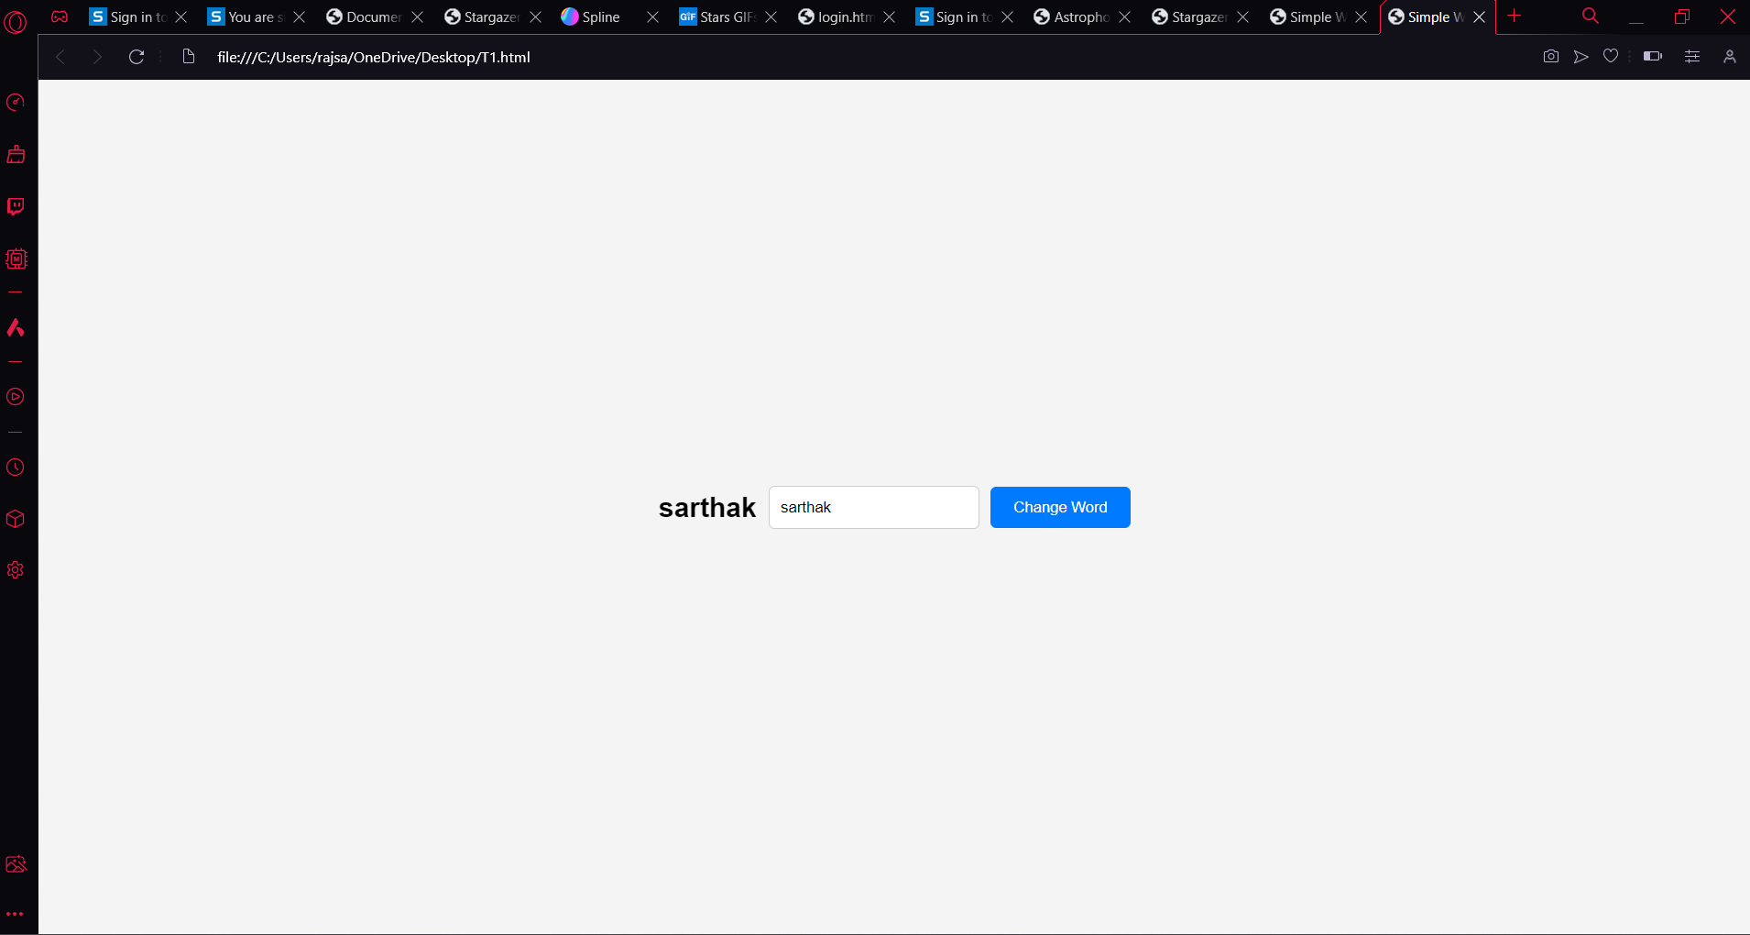

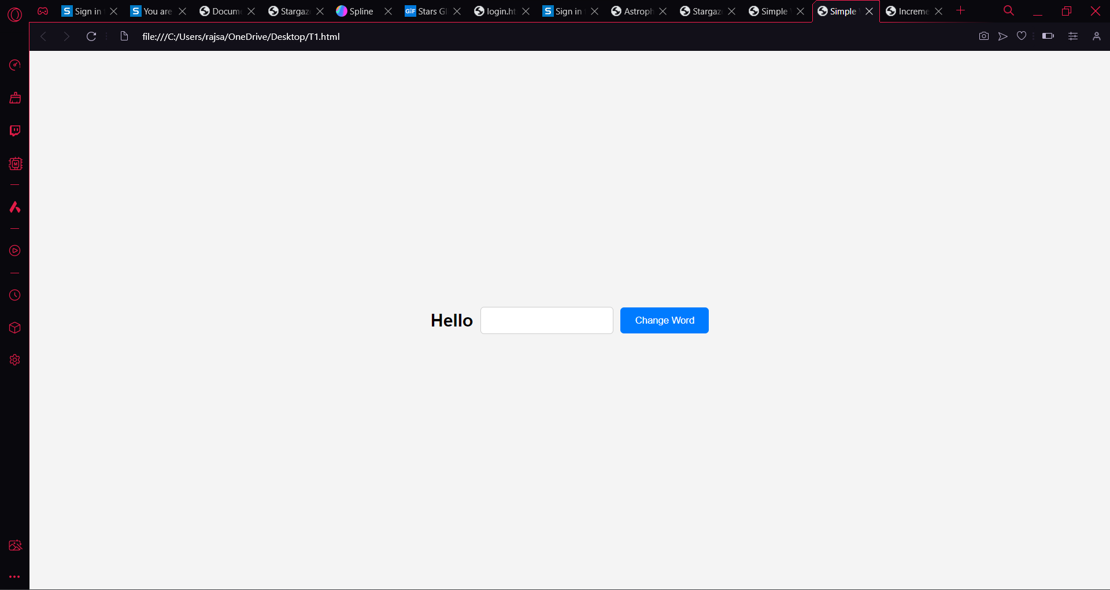

T2

<!DOCTYPE html>

<html lang="en">

<head>

<meta charset="UTF-8">

<meta name="viewport" content="width=device-width, initial-scale=1.0">

<title>Increment Counter</title>

<style>

body {

font-family: Arial, sans-serif;

display: flex;

justify-content: center;

align-items: center;

height: 100vh;

margin: 0;

background-color: #f4f4f4;

}

.container {

text-align: center;

}

#count {

font-size: 24px;

transition: font-size 0.2s ease;

margin-bottom: 20px;

}

button {

padding: 10px 20px;

background-color: #007bff;

color: white;

border: none;

border-radius: 5px;

cursor: pointer;

transition: background-color 0.3s ease;

}

button:hover {

background-color: #0056b3;

}

</style>

</head>

<body>

<div class="container">

<p id="count">0</p>

<button onclick="incrementCounter()">Increase Size</button>

</div>

<script>

var count = 0;

var countElement = document.getElementById("count");

function incrementCounter() {

count++;

countElement.innerText = count;

updateFontSize();

}

function updateFontSize() {

countElement.style.fontSize = (24 + count \* 2) + "px"; /\* Increase font size dynamically \*/

}

</script>

</body>

</html>

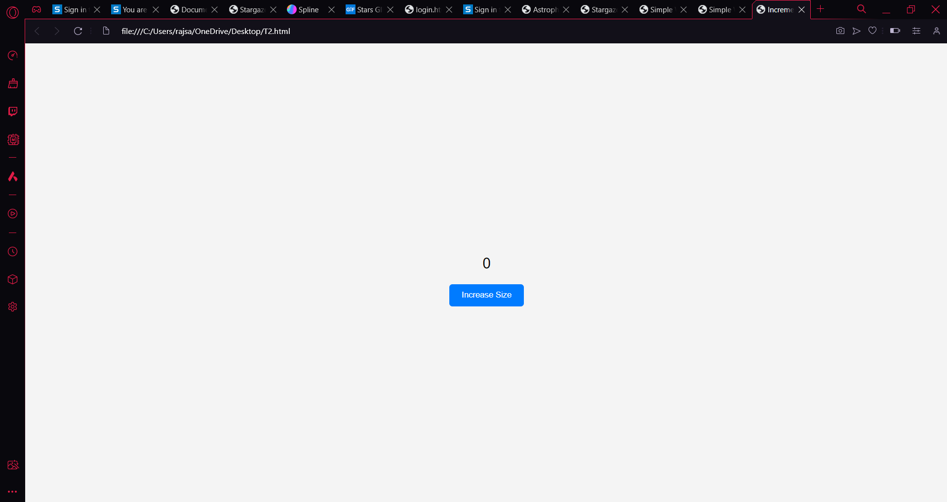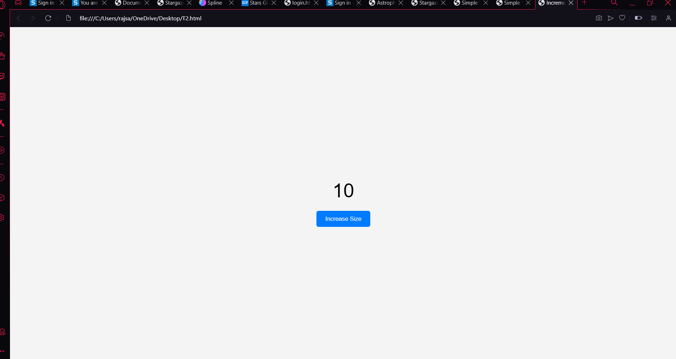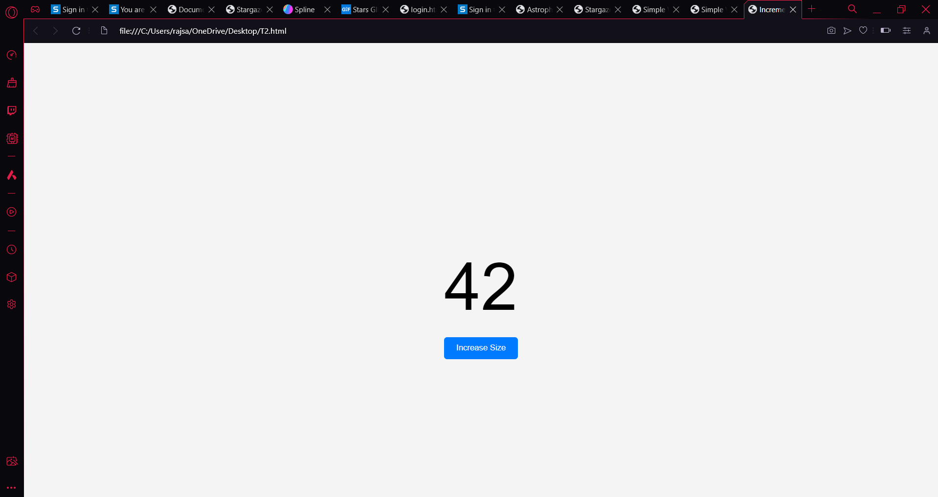

T3

<!DOCTYPE html>

<html lang="en">

<head>

<meta charset="UTF-8">

<meta name="viewport" content="width=device-width, initial-scale=1.0">

<title>Increment Counter</title>

<style>

body {

font-family: Arial, sans-serif;

display: flex;

justify-content: center;

align-items: center;

height: 100vh;

margin: 0;

background-color: #f4f4f4;

}

.container {

text-align: center;

}

#countList {

list-style-type: none;

padding: 0;

margin-bottom: 20px;

}

.countItem {

font-size: 24px;

transition: font-size 0.2s ease;

}

button {

padding: 10px 20px;

background-color: #007bff;

color: white;

border: none;

border-radius: 5px;

cursor: pointer;

transition: background-color 0.3s ease;

}

button:hover {

background-color: #0056b3;

}

</style>

</head>

<body>

<div class="container">

<ul id="countList"></ul>

<button onclick="incrementCounter()">Increment</button>

</div>

<script>

var count = 0;

var countList = document.getElementById("countList");

function incrementCounter() {

count++;

addListItem(count);

}

function addListItem(number) {

var listItem = document.createElement("li");

listItem.textContent = number;

listItem.classList.add("countItem");

updateFontSize(listItem);

countList.appendChild(listItem);

}

function updateFontSize(element) {

var fontSize = 24 + count \* 2; /\* Increase font size dynamically \*/

element.style.fontSize = fontSize + "px";

}

</script>

</body>

</html>

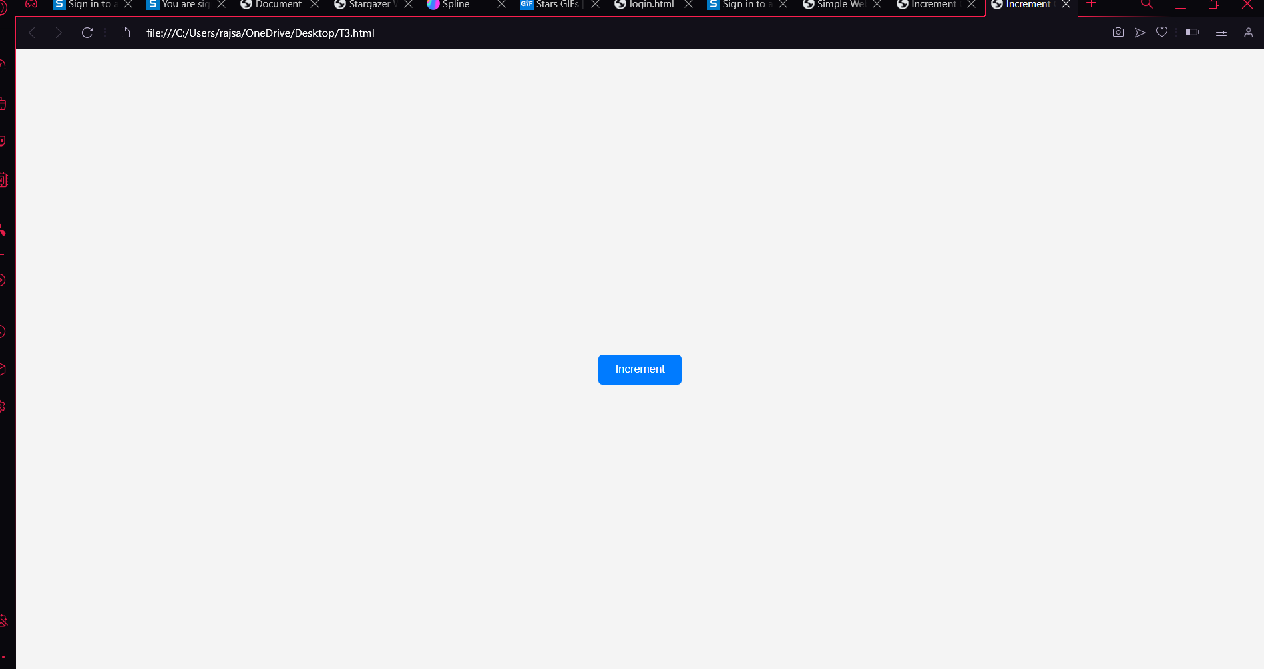

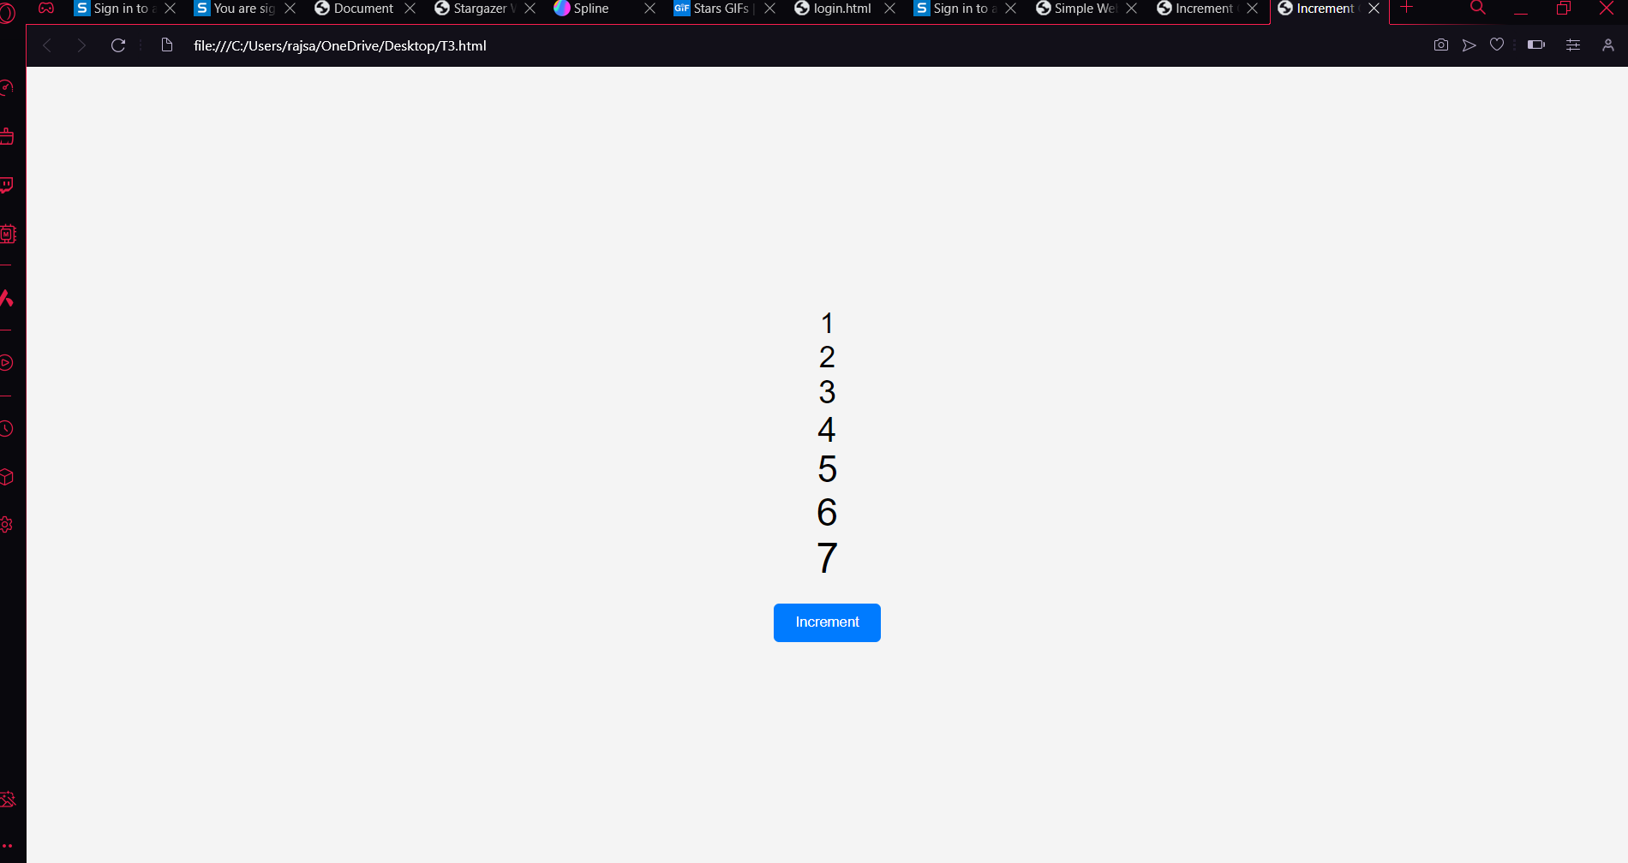

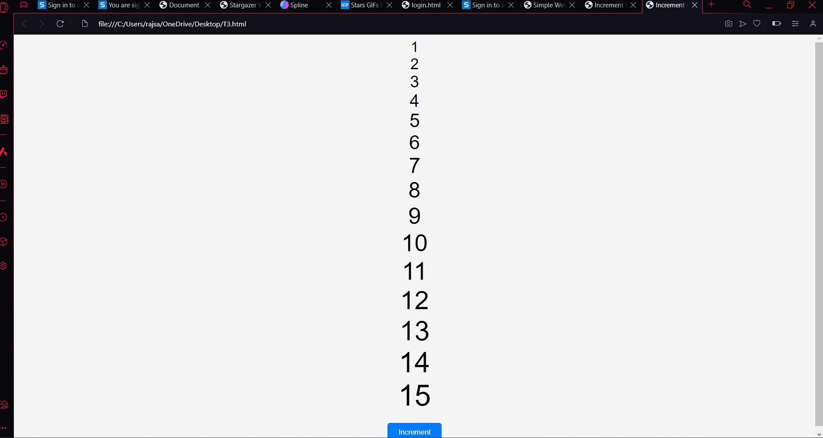

T4

<!DOCTYPE html>

<html lang="en">

<head>

<meta charset="UTF-8">

<meta name="viewport" content="width=device-width, initial-scale=1.0">

<title>Add Rows to Table</title>

<style>

table {

border-collapse: collapse;

width: 50%;

margin: 20px auto;

}

th, td {

border: 1px solid #dddddd;

padding: 8px;

text-align: left;

}

th {

background-color: #f2f2f2;

}

</style>

</head>

<body>

<table id="myTable">

<tr>

<th>Row</th>

<th>Sum</th>

</tr>

<tr>

<td>1</td>

<td>1</td>

</tr>

<tr>

<td>2</td>

<td>1</td>

</tr>

</table>

<button onclick="addRow()">Add Row</button>

<script>

function addRow() {

var table = document.getElementById("myTable");

var rows = table.getElementsByTagName("tr");

var lastRow = rows[rows.length - 1];

var prevRow = lastRow.previousElementSibling;

var sum = parseInt(lastRow.lastElementChild.innerText) + parseInt(prevRow.lastElementChild.innerText);

var newRow = table.insertRow(-1);

var cell1 = newRow.insertCell(0);

var cell2 = newRow.insertCell(1);

cell1.innerText = parseInt(lastRow.firstElementChild.innerText) + 1;

cell2.innerText = sum;

}

</script>

</body>

</html>

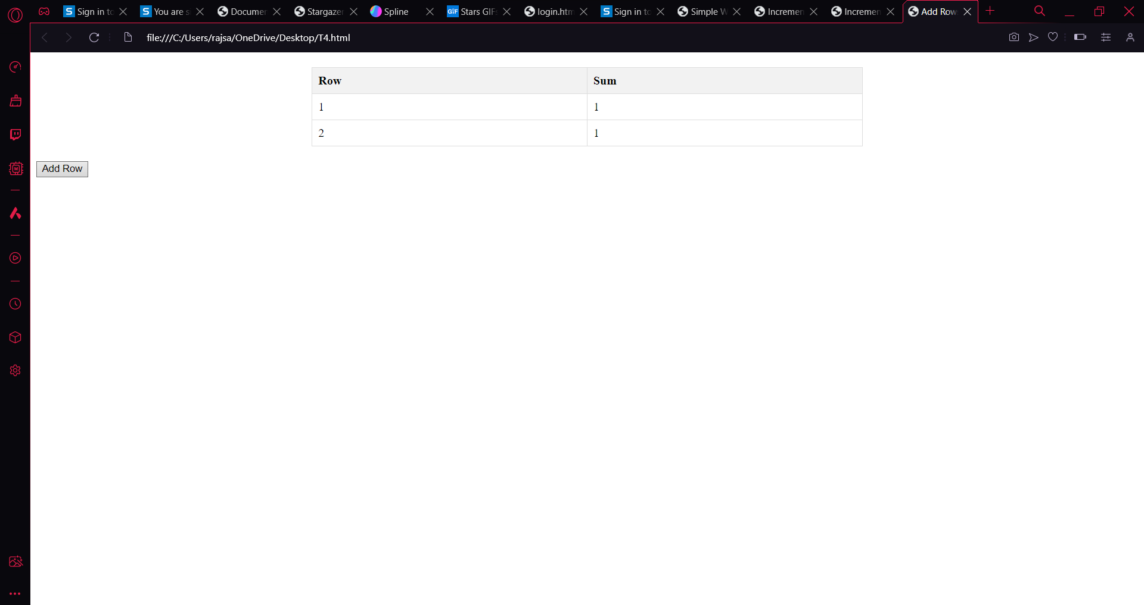

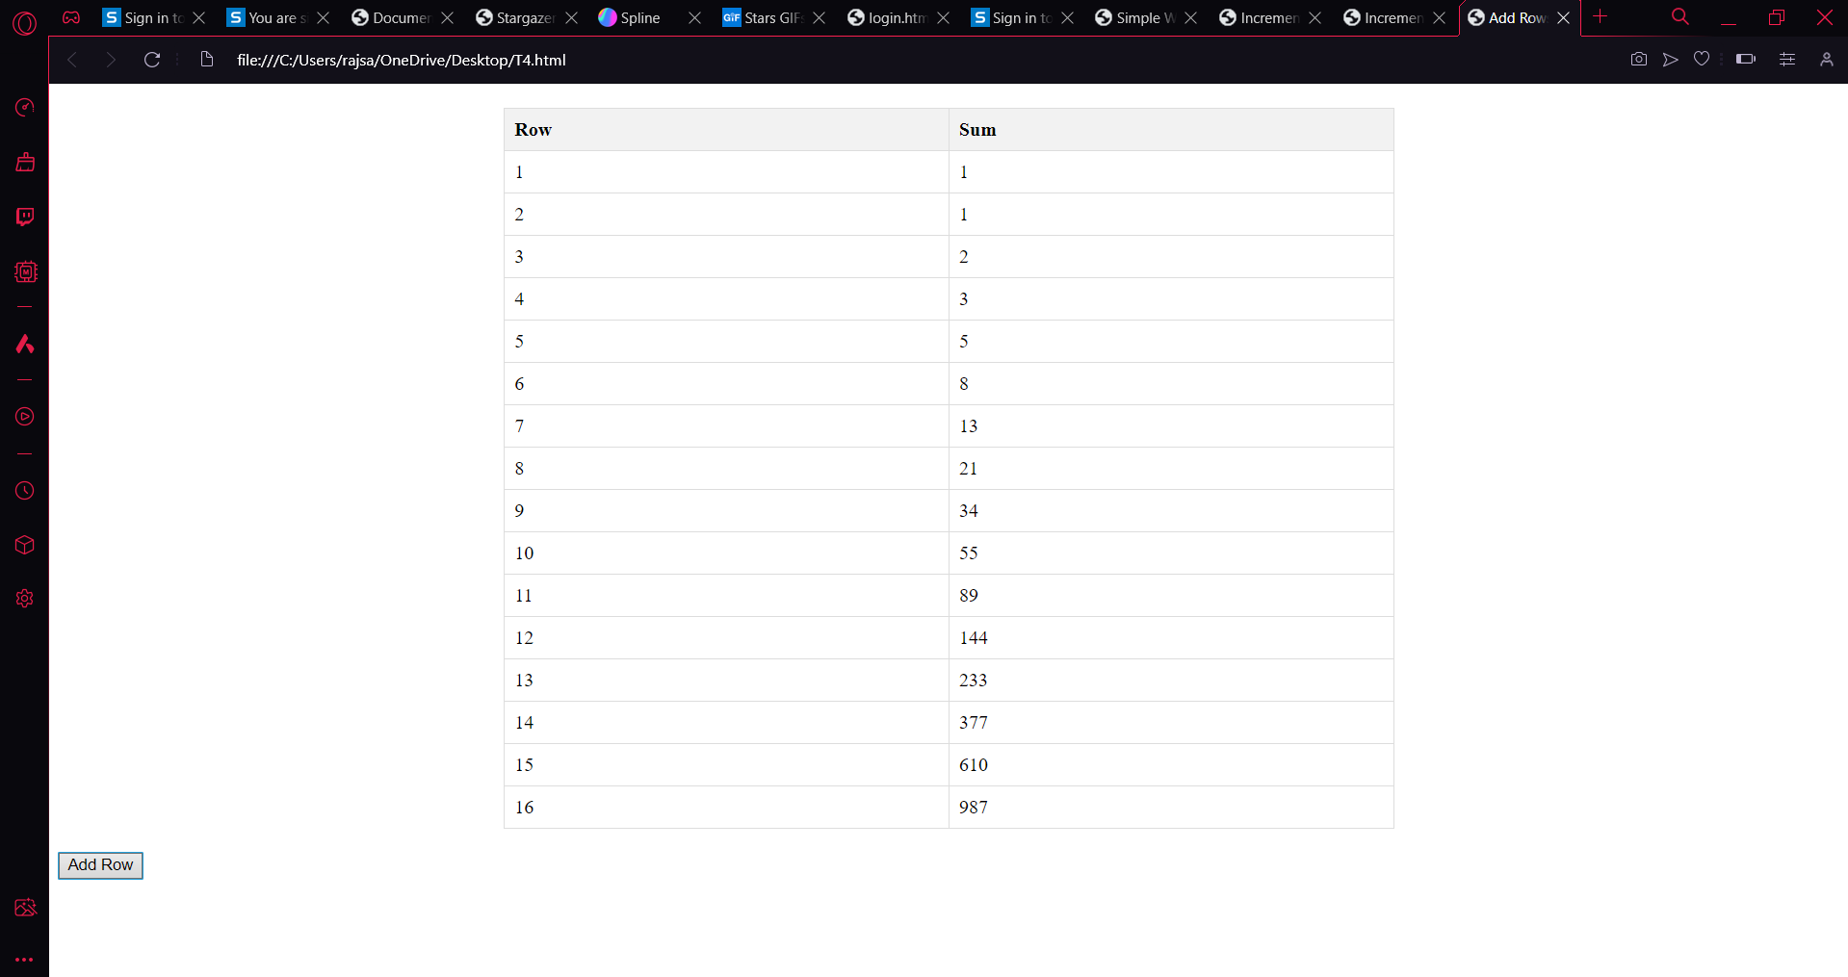

T5

<!DOCTYPE html>

<html lang="en">

<head>

<meta charset="UTF-8">

<meta name="viewport" content="width=device-width, initial-scale=1.0">

<title>Simple Calculator</title>

<style>

body {

font-family: Arial, sans-serif;

display: flex;

justify-content: center;

align-items: center;

height: 100vh;

margin: 0;

background-color: #f9f9f9;

}

.container {

text-align: center;

background-color: #fff;

padding: 20px;

border-radius: 10px;

box-shadow: 0 0 10px rgba(0, 0, 0, 0.1);

}

input[type="text"] {

padding: 10px;

margin: 5px;

width: 100px;

border: 1px solid #ccc;

border-radius: 5px;

font-size: 16px;

}

button {

padding: 10px 20px;

margin: 5px;

background-color: black;

color: white;

border: none;

border-radius: 5px;

cursor: pointer;

transition: background-color 0.3s ease, transform 0.2s ease;

font-size: 16px;

outline: none;

}

button:hover {

background-color: #333;

transform: scale(1.1);

}

#result {

font-size: 24px;

margin-top: 20px;

color: #333;

}

</style>

</head>

<body>

<div class="container">

<input type="text" id="input1" placeholder="Enter number 1">

<input type="text" id="input2" placeholder="Enter number 2"><br>

<button onclick="add()">+</button>

<button onclick="subtract()">-</button>

<button onclick="multiply()">\*</button>

<button onclick="divide()">/</button><br>

<div id="result"></div>

</div>

<script>

function add() {

var num1 = Number.parseInt(document.getElementById("input1").value);

var num2 = Number.parseInt(document.getElementById("input2").value);

var result = num1 + num2;

document.getElementById("result").innerText = "Result: " + result;

}

function subtract() {

var num1 = Number.parseInt(document.getElementById("input1").value);

var num2 = Number.parseInt(document.getElementById("input2").value);

var result = num1 - num2;

document.getElementById("result").innerText = "Result: " + result;

}

function multiply() {

var num1 = Number.parseInt(document.getElementById("input1").value);

var num2 = Number.parseInt(document.getElementById("input2").value);

var result = num1 \* num2;

document.getElementById("result").innerText = "Result: " + result;

}

function divide() {

var num1 = Number.parseInt(document.getElementById("input1").value);

var num2 = Number.parseInt(document.getElementById("input2").value);

var result = num1 / num2;

document.getElementById("result").innerText = "Result: " + result;

}

</script>

</body>

</html>

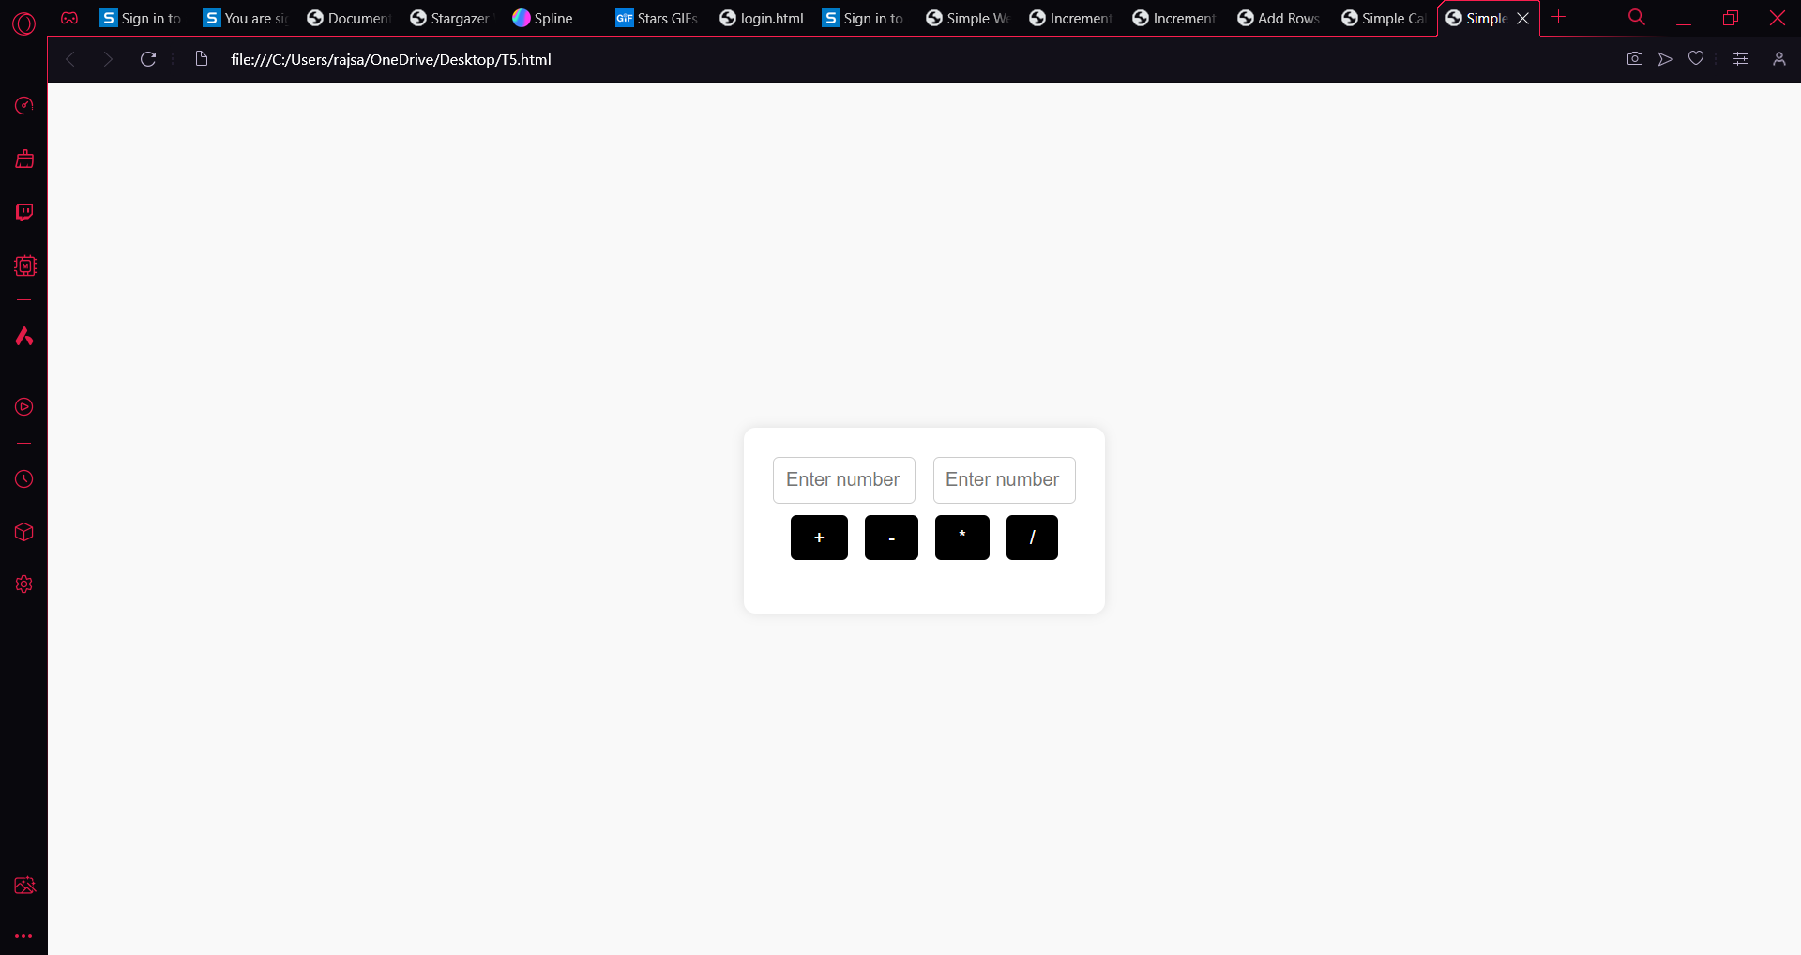

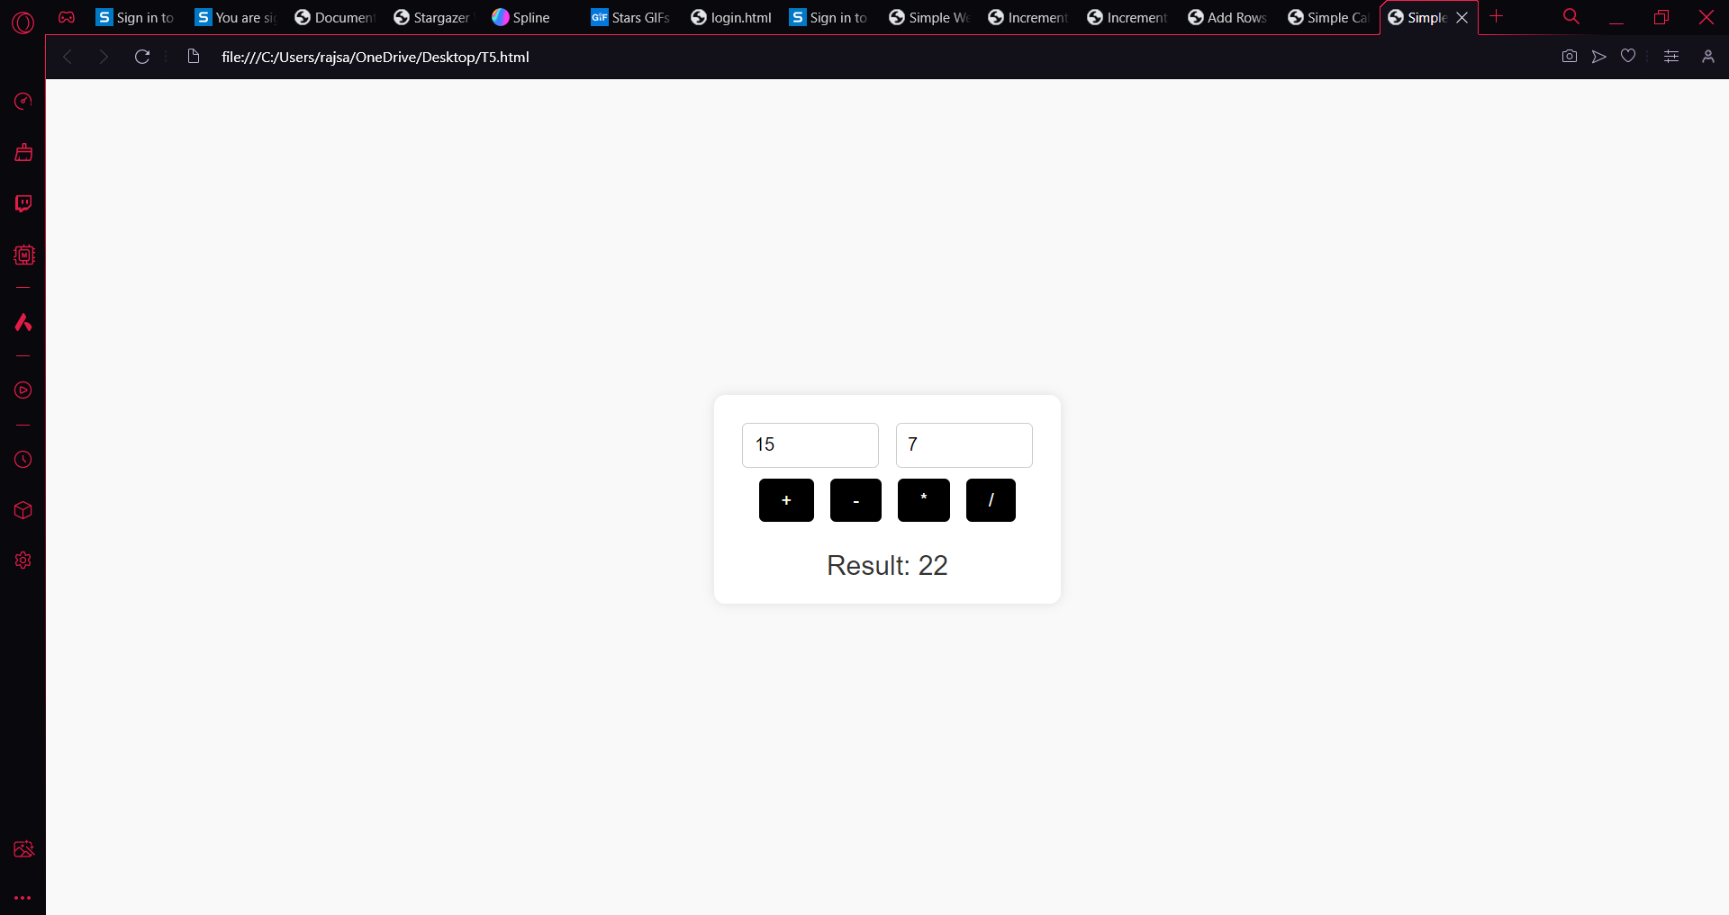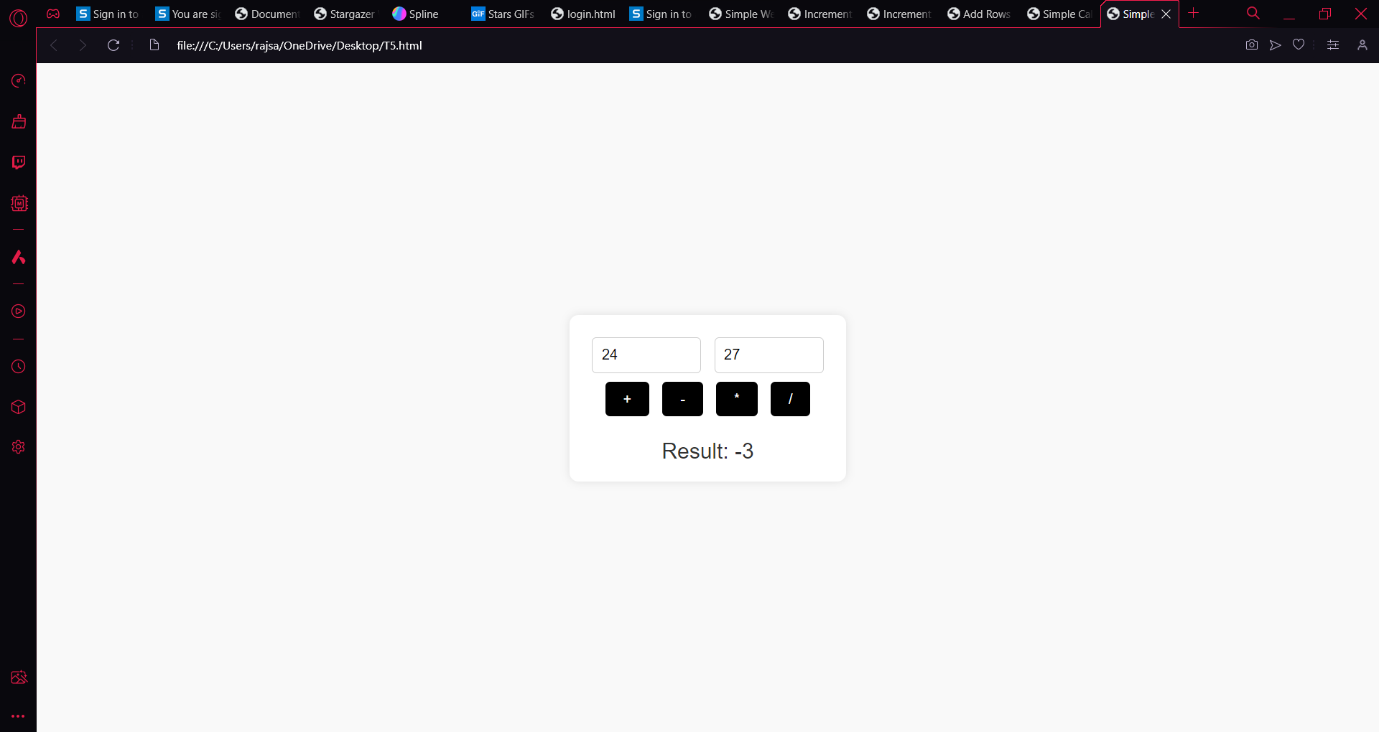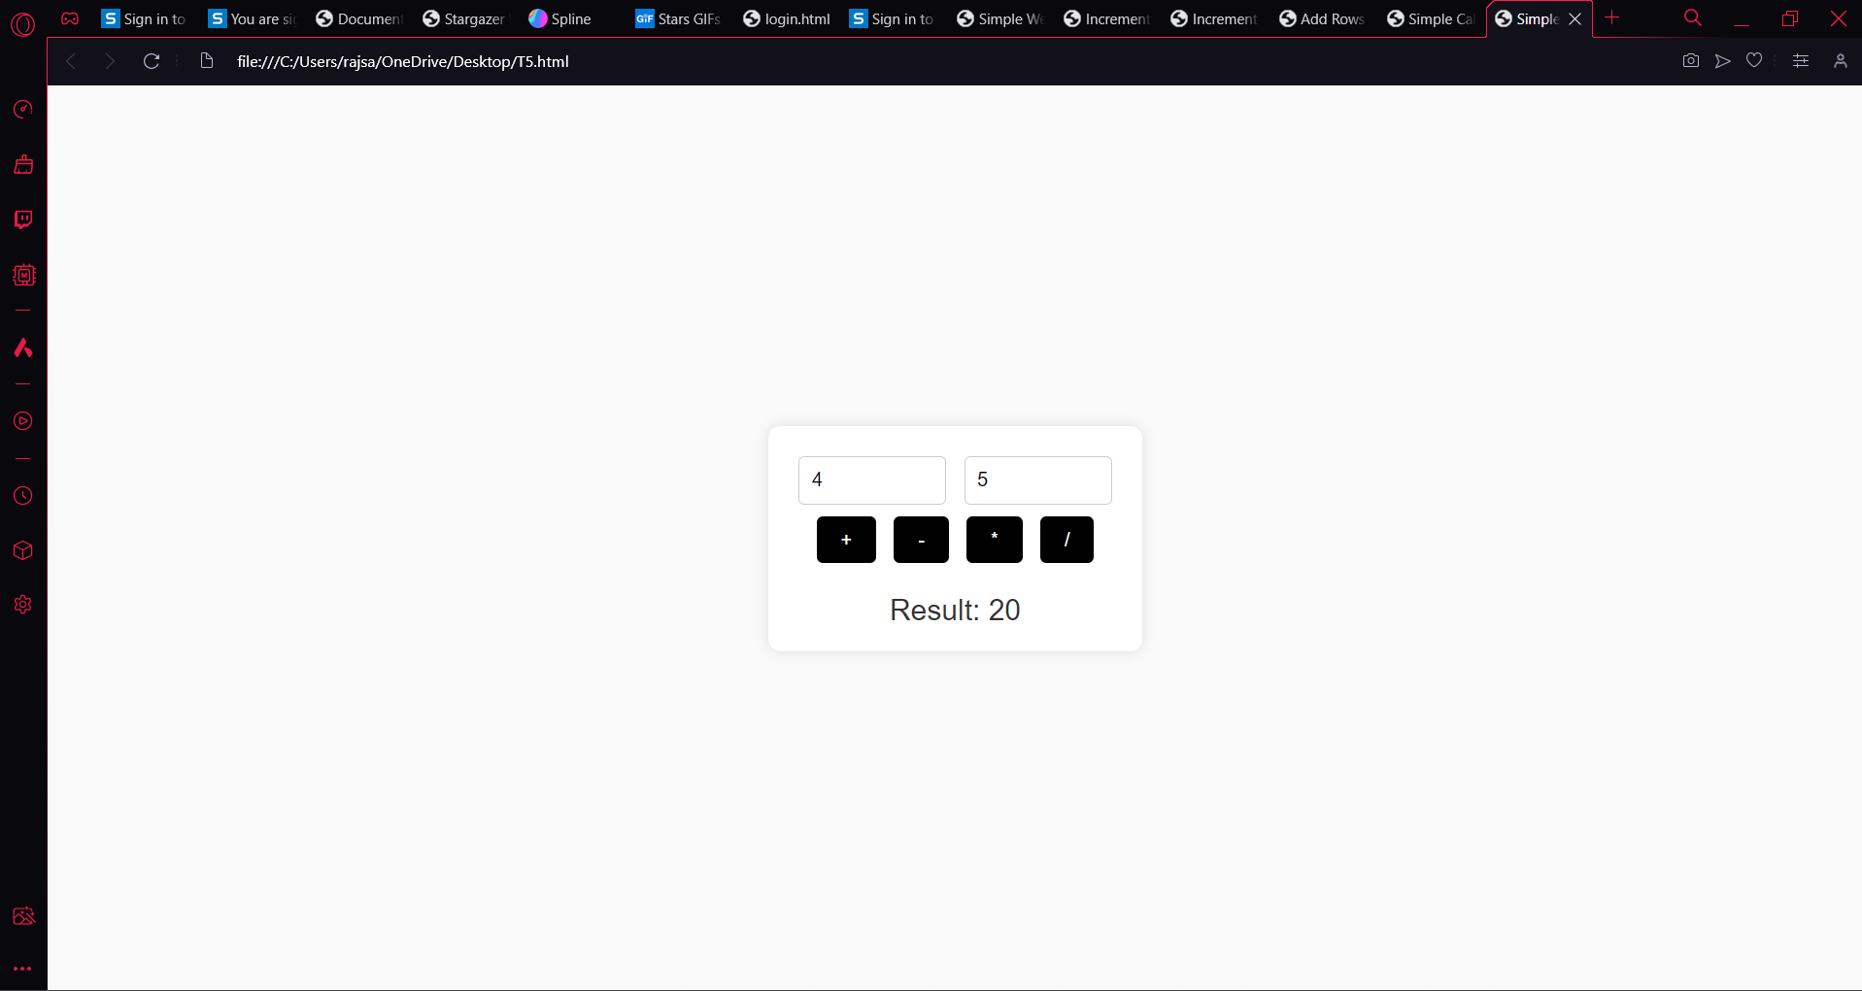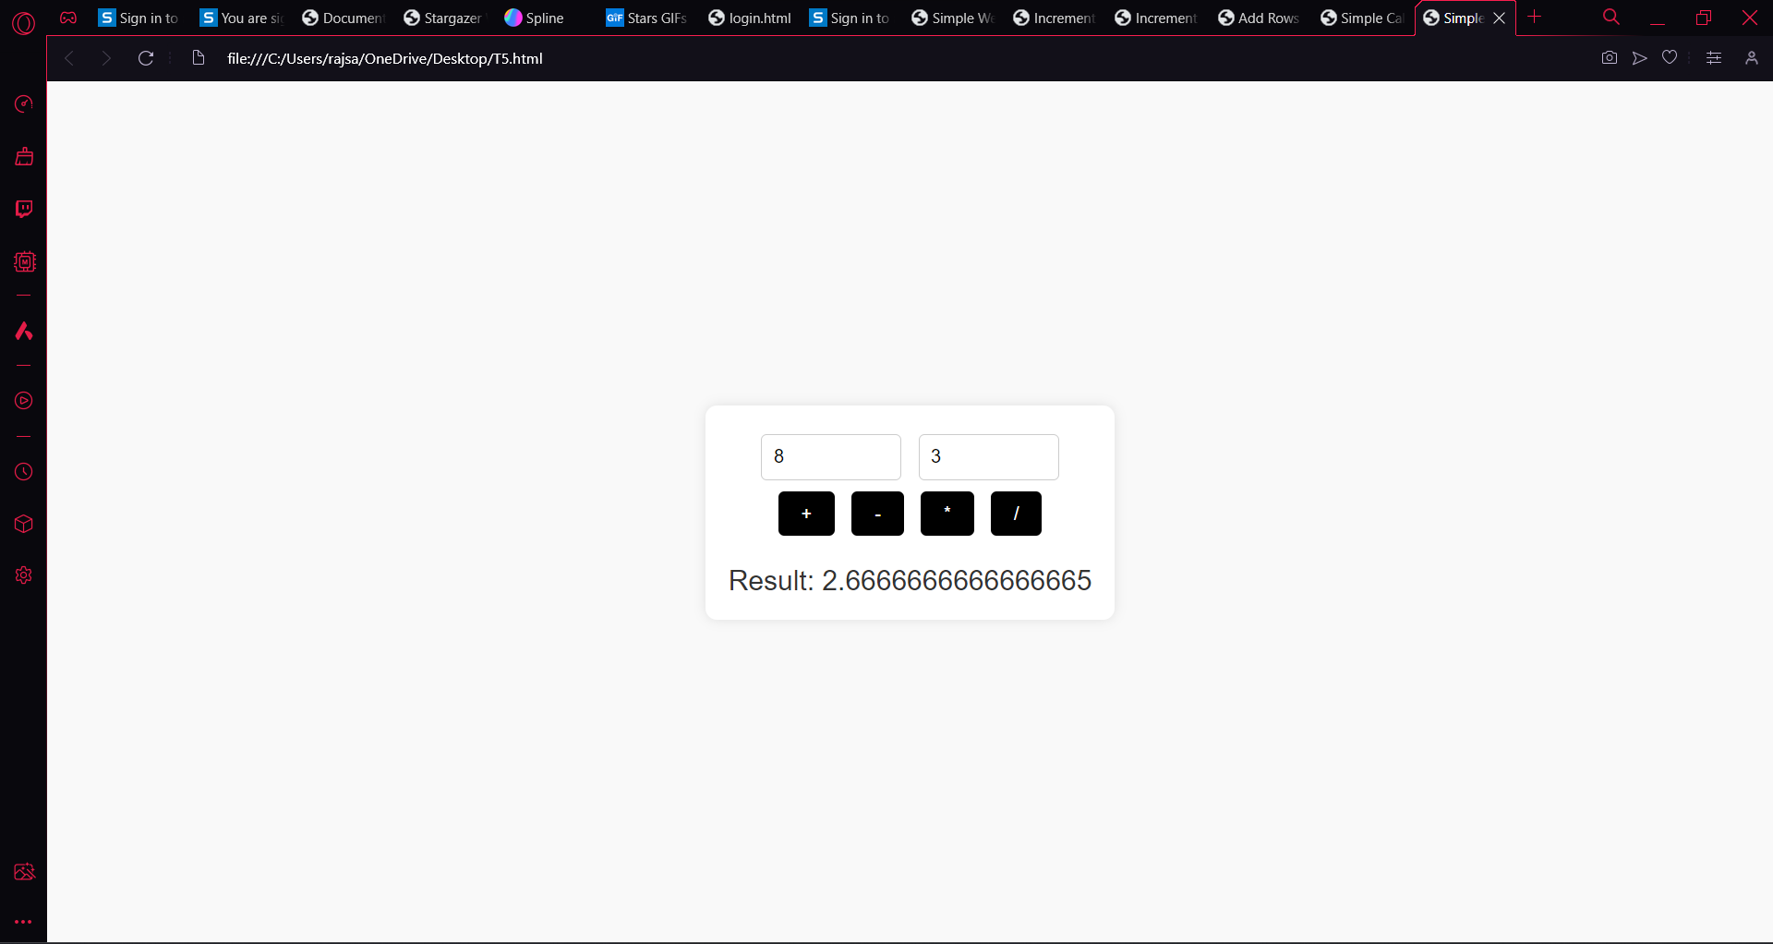

T7

<!DOCTYPE html>

<html lang="en">

<head>

<meta charset="UTF-8">

<meta name="viewport" content="width=device-width, initial-scale=1.0">

<title>Tip Calculator</title>

<style>

body {

font-family: Arial, sans-serif;

display: flex;

justify-content: center;

align-items: center;

height: 100vh;

margin: 0;

background-color: #f4f4f4;

}

.container {

background-color: #fff;

border-radius: 10px;

box-shadow: 0 0 10px rgba(0, 0, 0, 0.1);

padding: 20px;

width: 300px;

}

.container label {

display: block;

font-size: 16px;

margin-bottom: 5px;

color: #333;

}

.container input[type="number"] {

padding: 10px;

margin-bottom: 10px;

width: 100%;

border: 1px solid #ccc;

border-radius: 5px;

font-size: 16px;

box-sizing: border-box;

}

.container button {

padding: 10px 20px;

background-color: #007bff;

color: white;

border: none;

border-radius: 5px;

cursor: pointer;

transition: background-color 0.3s ease, transform 0.2s ease;

font-size: 16px;

outline: none;

width: 100%;

}

.container button:hover {

background-color: #0056b3;

transform: scale(1.05);

}

#result {

font-size: 18px;

margin-top: 20px;

color: #333;

text-align: left;

}

</style>

</head>

<body>

<div class="container">

<label for="billAmount">Bill Amount (₹):</label>

<input type="number" id="billAmount" min="0" step="0.01"><br>

<label for="tipPercentage">Tip Percentage (%):</label>

<input type="number" id="tipPercentage" min="0" step="1"><br>

<label for="splitNumber">Number of People to Split:</label>

<input type="number" id="splitNumber" min="1"><br>

<button onclick="calculateTip()">Calculate Tip</button><br>

<div id="result"></div>

</div>

<script>

function calculateTip() {

var billAmount = parseFloat(document.getElementById("billAmount").value);

var tipPercentage = parseFloat(document.getElementById("tipPercentage").value);

var splitNumber = parseInt(document.getElementById("splitNumber").value);

if (isNaN(billAmount) || isNaN(tipPercentage) || isNaN(splitNumber) || billAmount <= 0 || tipPercentage < 0 || splitNumber <= 0) {

document.getElementById("result").innerText = "Please enter valid values.";

return;

}

var tipAmount = (billAmount \* tipPercentage) / 100;

var totalAmount = billAmount + tipAmount;

var splitAmount = totalAmount / splitNumber;

document.getElementById("result").innerHTML = `

Tip Amount: ₹${tipAmount.toFixed(2)}<br>

Total Amount: ₹${totalAmount.toFixed(2)}<br>

Amount per Person: ₹${splitAmount.toFixed(2)} each

`;

}

</script>

</body>

</html>

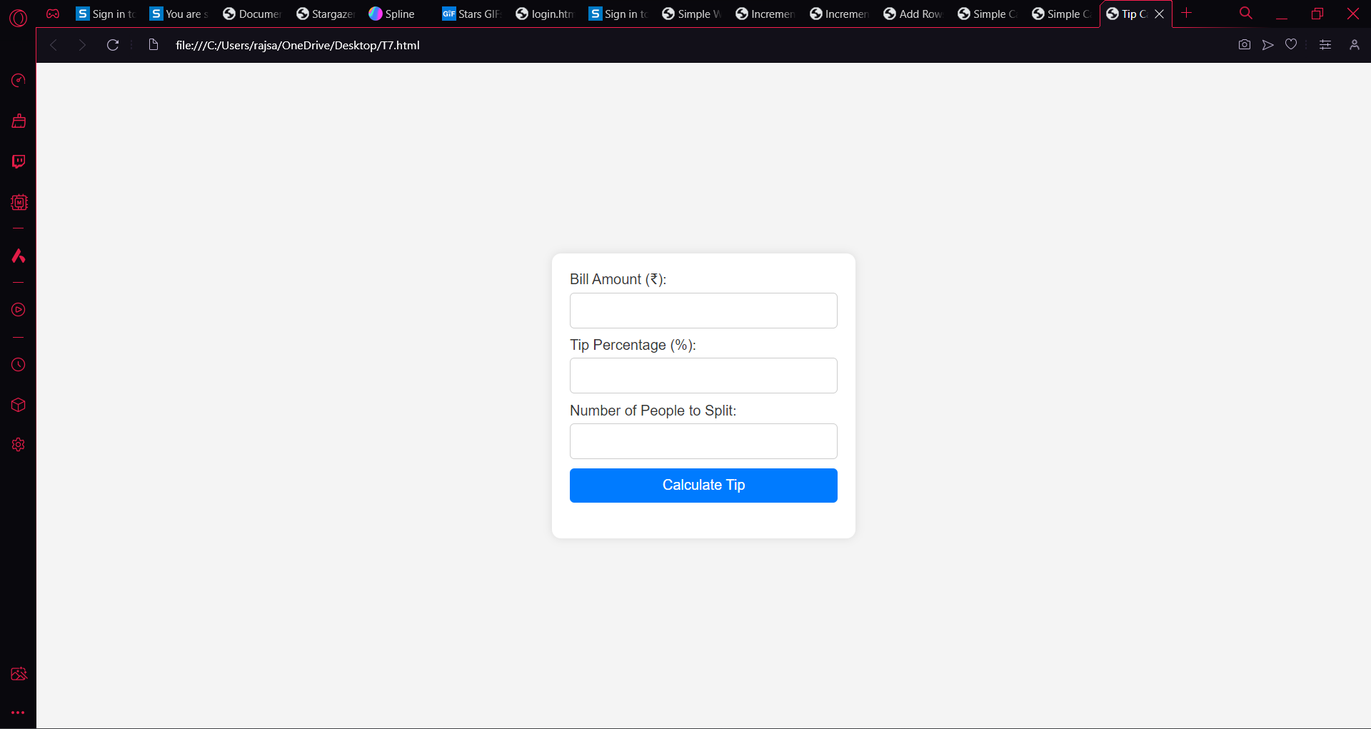

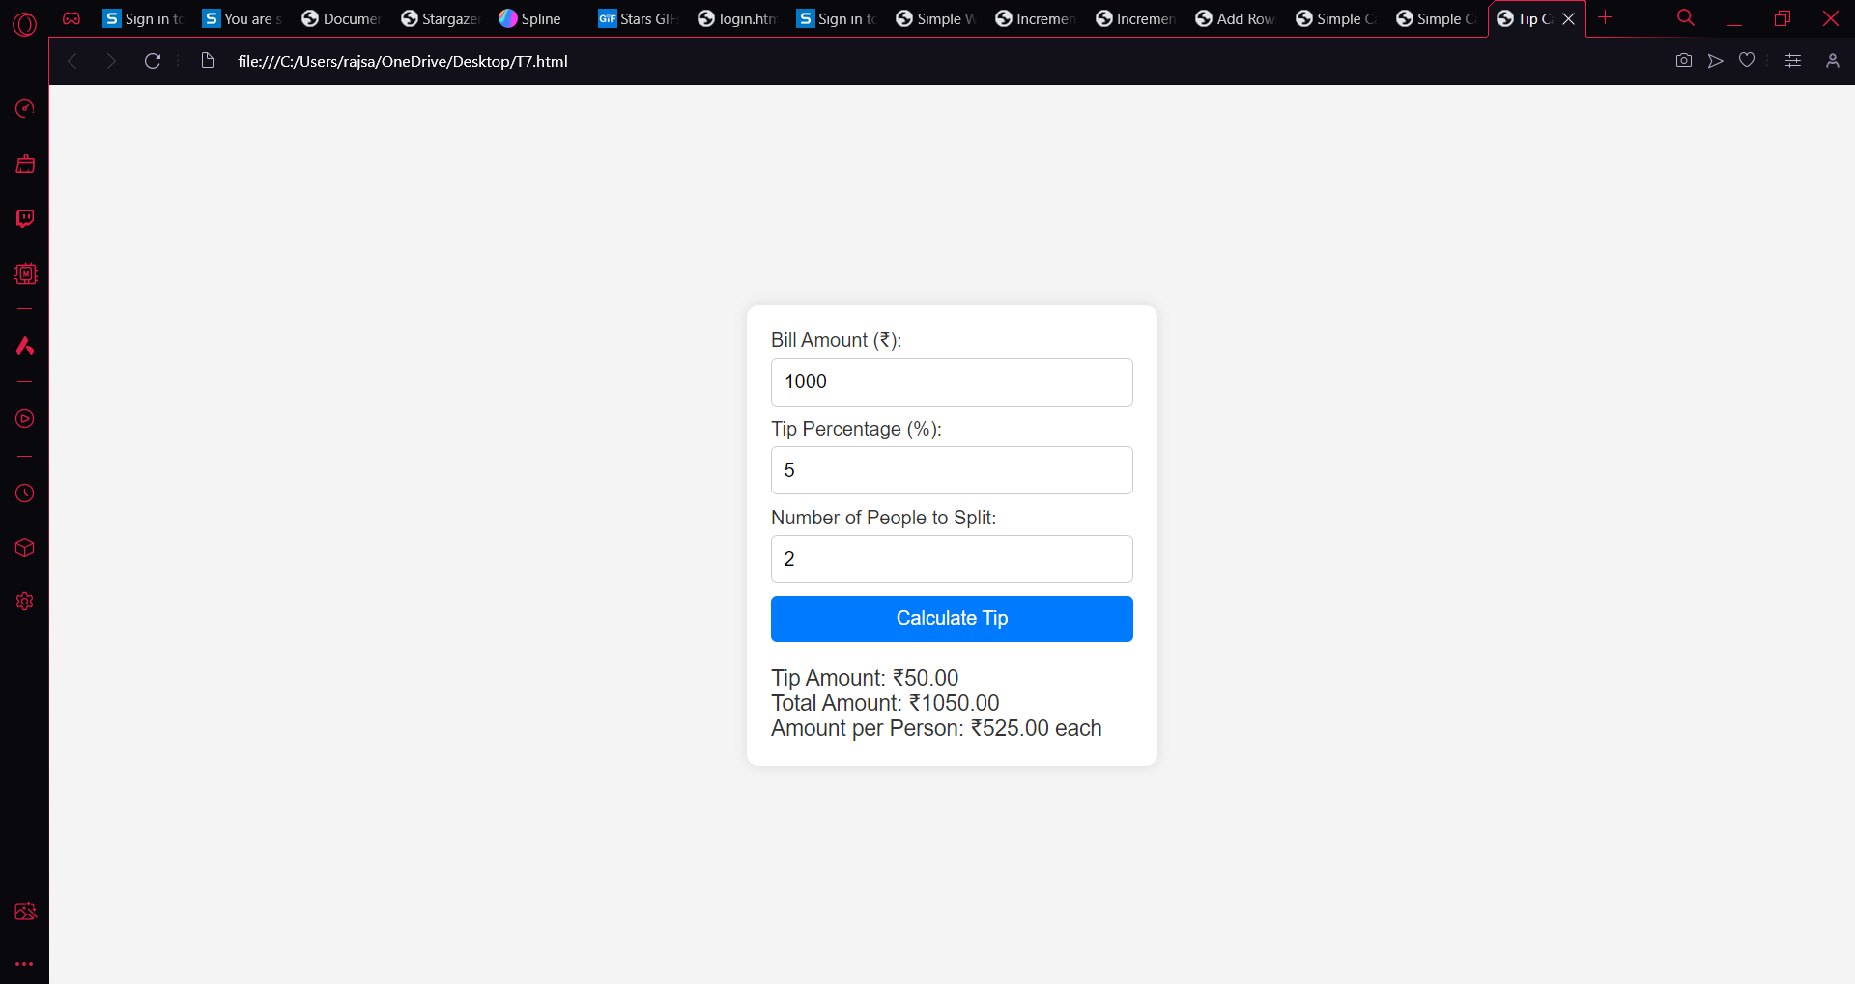

T6

<!DOCTYPE html>

<html lang="en">

<head>

<meta charset="UTF-8">

<meta name="viewport" content="width=device-width, initial-scale=1.0">

<title>Dynamic Webpage</title>

<style>

body {

font-family: Arial, sans-serif;

background-color: #f9f9f9;

margin: 0;

padding: 0;

}

.container {

max-width: 600px;

margin: 50px auto;

text-align: center;

padding: 20px;

background-color: #fff;

border-radius: 10px;

box-shadow: 0 0 10px rgba(0, 0, 0, 0.1);

}

h1 {

color: #333;

}

p {

color: #666;

text-align: left;

}

ul {

list-style-type: disc;

margin-left: 20px;

}

button {

padding: 10px 20px;

background-color: #007bff;

color: white;

border: none;

border-radius: 5px;

cursor: pointer;

transition: background-color 0.3s ease, transform 0.2s ease;

font-size: 16px;

outline: none;

}

button:hover {

background-color: #0056b3;

transform: scale(1.1);

}

</style>

</head>

<body>

<button onclick="makePage();">Click Here</button>

<script>

function makePage() {

// Remove the button

var button = document.querySelector('button');

button.remove();

// Create the container div

var container = document.createElement('div');

container.classList.add('container');

// Create and append the h1 element

var heading = document.createElement('h1');

heading.textContent = 'I am an H1';

container.appendChild(heading);

// Create and append the paragraph element with bullet points

var paragraph = document.createElement('p');

paragraph.textContent = 'This is a Paragraph Followed by a List';

var bulletList = document.createElement('ul');

var bullet1 = document.createElement('li');

bullet1.textContent = 'This is First';

var bullet2 = document.createElement('li');

bullet2.textContent = 'This is Second';

bulletList.appendChild(bullet1);

bulletList.appendChild(bullet2);

paragraph.appendChild(bulletList);

container.appendChild(paragraph);

// Append the container to the body

document.body.appendChild(container);

}

</script>

</body>

</html>

